Evolving emulsion microcompartments via enzyme-mimicking amyloid-mediated interfacial catalysis

Peiyong Song¹, Jing Chen¹, Dan Zhao², Ke Shi¹, Runze Xu³, Mengyue Zhu¹, Li Zhao⁴*, E. Thomas Pashuck⁵, Liliang Ouyang³, Fang Jiao², Yiyang Lin¹*

¹ State Key Laboratory of Chemical Resource Engineering, Key Lab of Biomedical Materials of Natural Macromolecules(Beijing University of Chemical Technology, Ministry of Education), Beijing Laboratory of Biomedical Materials, Beijing University of Chemical Technology, Beijing 100029, China.
² Laboratory of Soft Matter Physics, Institute of Physics, Chinese Academy of Sciences Beijing 100190, China
³ Department of Mechanical Engineering, Tsinghua University, Beijing 100084, China
⁴ School of Light Industry, Beijing Technology & Business University (BTBU), Beijing 100048, China
⁵ Department of Bioengineering, Lehigh University, Bethlehem, PA 18015, USA
Email: zhaol@btbu.edu.cn; y.lin@mail.buct.edu.cn

Table of contents

S1. Materials and methods
S1.1. Materials
S1.2. Methods
S2. Supplementary figures
Figure S1-S23
Table S1

S1. Materials and methods
S1.1 Materials. Rink amide resin, Fmoc-protected amino acids, O-benzotriazole-N,N,N’,N’-tetramethyluronium-hexafluoro-phosphate (HBTU), piperidine and diisopropylethylamine (DIEA) were purchased from Bide. N,N'-dimethyl formamide (DMF), dichloromethane (DCM), ethyl diether, trifluoroacetic acid (TFA), triisopropylsilane (TIPS) were purchased from Aladdin. All the other reagents were used as received.

S1.2 Methods
Solid phase peptide synthesis (SPPS). All peptides were synthesized manually using standard fluorenyl methoxycarbonyl (Fmoc) chemistry. Fmoc-protected amino acids were activated with 4 molar equivalents of protected amino acids, 3.95 molar equivalents of HBTU, and 6 molar equivalents of DIPEA in DMF. The coupling solution was added to the resin and the coupling reaction was allowed to proceed for three hours. Deprotection to remove Fmoc protecting group was conducted in 20% piperidine/DMF. After coupling the last amino acid, a fatty acid (i.e., myristic acid, palmitic acid and stearic acid) was attached to the free amine with similar coupling protocol. Finally, the peptides were cleaved in a mixture of 95% TFA, 2.5% TIPS and 2.5% H₂O for three hours. After removing the solvent in vacuum, excess ether was added to precipitate peptide. The crude product was washed with ether three times and dried in vacuum before purification. Peptide purification was conducted on a reversed phase preparative high performance liquid chromatography (HPLC; Shimadzu) in an acetonitrile/water gradient under acidic conditions on a Phenomenex C18 Gemini NX column (10 micron pore size, a 110 Å particle size, 250 x 20 mm). The purified peptide mass was verified by analytical HPLC and mass spectroscopy.
Synthesis of FITC-APTES. To label the silica precursor, 10 mg FITC was reacted with 100 μL of 3-aminopropyltriethoxysilane (APTES) in 5 mL ethanol for 12 h in the dark. The precursor was used without further purification
Transmission electron microscopy (TEM). TEM measurements were performed on a JEM 2100F with an acceleration voltage of 200 kV, and the images were recorded by Orius camera. TEM samples were prepared using the negative-staining method. Briefly, a drop was deposited onto the carbon-coated 200 mesh copper grid for 5 min. The excess of solution was wiped away using a filter paper. Subsequently, the grid was stained with a drop of uranyl acetate (1.0 wt%) solution for 3 min. Excess staining agent was removed using a filter paper and the sample dried in air.
Atomic force microscopy (AFM). The KIV nanofibrils were initially dissolved in water and diluted with HEPES buffer (10 mM, pH 7.5). The nanofibril solution was incubated on freshly cleaved mica disk (4 mm in diameter) at room temperature for 20 mins, then thoroughly rinsed by 200 µL 10 mM HEPES-NaOH, pH 7.5 buffer and directly imaged in same buffer by AFM. AFM imaging was performed in tapping mode using silicon probes (SNL-10 A, k=0.35 N/m, Bruker, USA) with Multimode 8 (Bruker, USA) at room temperature. AFM images were analyzed using Nanoscope Analysis software version 3.00 (64 bit).
Fluorescence characterization. Typically, Thioflavin T (ThT, 10 μM) was added to peptide solution before the measurements and the fluorescence spectra were recorded on Tecan infinite E PLEX plate reader with the excitation of 435 nm light. Nile Red assay was performed by incubating peptide solutions with 10 μM Nile Red in a 96-well plate and the fluorescence spectra were recorded on Tecan infinite E PLEX plate reader with the excitation of 543 nm light.
Circular dichroism (CD). CD spectra were recorded using a Jasco-815 circular dichroism spectrophotometer at different temperatures. The concentration of peptide samples was 0.5 mM. The samples were loaded into a rectangular quartz cell with the light path length of 1 mm. All scans were performed at 0.2 nm intervals with averaging time of 3 seconds and spectra were averaged across three scans.
Interfacial tension. Interfacial tension and the interfacial rheological parameters were measured on OSA 60 Optical Surface Analyzer. The interfacial tension of a water–oil interface was achieved through the acquisition of a silhouette of an axisymmetric fluid droplet, and iterative fitting of the Young–Laplace equation that balances gravitational deformation of the drop with the restorative interfacial tension. The image of the drop was captured by a CCD camera and transferred to the data acquisition computer.
Preparation of amyloid nanofibrils: Typically, a desired amount of tridecapeptide KIV was dissolved in water to ensure complete dissolution of the powder, which was diluted with HEPES buffer to reach desired concentration. The final concentration of HEPES buffer was 10 mM (pH 7.5).
Preparation of Pickering emulsion: (a) To prepare Pickering emulsions stabilized by mature amyloid fibrils, an aqueous phase containing mature KIV fibrils (0.7 mL) was mixed with chloroform (0.3 mL), followed by homogenization for emulsification for 3 min. The emulsion samples were sealed and incubated at room temperature before further characterization. (b) The same protocol was applied with a range of organic solvents including hexanol, iso-octanol, octanol, n-butanol, dichloroethane (DCE), dichloromethane (DCM), chloroform, ethyl acetate (EA), methyl tert-butyl ether (MTBE), toluene, hexane and heptane.
Evaluation of catalytic activity of amyloid nanofibrils. (a) To test the hydrolase-like activity, fresh KIV solutions or mature fibril solution (60 h incubation) were prepared in HEPES (10 mM, pH 7.5). A freshly prepared solution of p-nitrophenyl acetate (PNPA) in ethanol was added to reach a concentration of 0.5 mM. Immediately, the UV-vis absorbance at 400 nm was recorded on a UV-vis spectrometer at room temperature over a period of 5 min. To determine the reaction rate, the calibration curve of p-nitrophenol (PNP) was measured in HEPES (10 mM, pH 7.5). (b) Similarly, the hydrolase-like activity of KIV nanofibrils was also evaluated with fluorogenic substrates including 1-propyl pyrene-3,6,8-trisulfonate (PrPTS) and 4-methylumbelliferyl acetate (MU-Ac), which was converted into HPTS and MU, respectively. The fluorescence emission at 520 nm (for HPTS) and 450 nm (for MU) was monitored to investigate the hydrolysis reaction. (c) To evaluate the catalytic hydrolysis of fluorogenic substrates at oil/water interface, a Pickering emulsion was prepared following the above method, in which PrPTS and MU-Ac were loaded in aqueous and organic phase, separately. The time-varied fluorescence microscopy images were captured and the fluorescence at the interface was monitored on microscope at varied incubation time to monitor the production of HPTS (λ_{em} = 520 nm) and MU (λ_{em} = 450 nm).
3D printing. The 3D printing process was conducted at room temperature with an extrusion-based 3D printer (Biomaker 2, SunP Biotech). The structures to be printed were first designed in CAD software (SOLIDWORKS® 2021), and then sliced into printing paths in G-Code format with the built-in slicing function of the 3D printer. The emulsion gels to be printed was loaded into a 5 mL syringe, which was then transferred to the printer nozzle. The printing was carried out with the printing speed and extrusion speed set to 1.5 mm s⁻¹ and 2 mm³ s⁻¹. Photos of the printed structures were taken for demonstration and analysis.
Rheological test. The gel rheological properties were tested with a Rheometer (MCR 302, Anton Paar), that is equipped with 25 mm diameter parallel plate (PP25, Anton Paar). To mimick change in gel rheology after extrusion-based printing, the gels was formulated and loaded into 5 mL syringes, which were then extruded onto the rheolometer platform. The gap distance between the rheometer platform and the parallel plate was set to be 0.4 mm, which allows for loading gel samples of 500 μL per test. The storage modulus and loss modulus of the gels were tested against shear strain that varied from 10⁻³ % to 10³ %. The viscosity of the gels were assessed by varing shear rate from 10⁻² to 10³ s⁻¹. All rheological tests were performed under room temperature at 22°C.
Emulsion evolution through catalytic hydrolysis of p-nitrophenol ester. (a) Time-dependent interfacial tension analysis: Typically, a KIV nanofibril solution (0.2 mM) was prepared in HEPES (10 mM, pH 7.5) and a solution of p-nitrophenyl ester (n = 0~16) in chloroform was prepared with the concentration of 1.0 mM. A drop of chloroform containing substrates was ejected into the aqueous solution of KIV, and the image of the drop was captured by a CCD camera and transferred to the data acquisition computer. (b) Emulsion evolution: a KIV nanofibril solution (0.2 mM, 0.7 mL) was mixed with chloroform containing p-nitrophenyl ester (1 mM, 0.3 mL). The mixture was homogenized for 30 sec to obtain a Pickering emulsion in the bottom phase. The emulsion droplets were stained with HPTS and imaged under fluorescence microscope. Macroscopic photos of emulsion systems were also recorded to evaluate the stability of Pickering emulsions. (c) Phase inversion and the formation of HIPE: a KIV nanofibril solution (0.2 mM, 0.75 mL) was mixed with chloroform containing p-nitrophenyl ester (1 mM, 0.25 mL). The mixture was homogenized for 30 sec to obtain a Pickering emulsion in the bottom phase. After incubation for different time periods, the o/w emulsion was further homogenized to obtain w/o Pickering emulsion. The emulsion droplets were stained with HPTS and imaged with fluorescence microscopy.
Emulsion evolution through biomineralization. Typically, a KIV nanofibril solution (0.2 mM, 0.7 mL) was mixed with chloroform containing TEOS (0.3 mL). The mixture was homogenized for 30 sec to obtain a Pickering emulsion in the bottom phase.

S2. Supplementary Figures
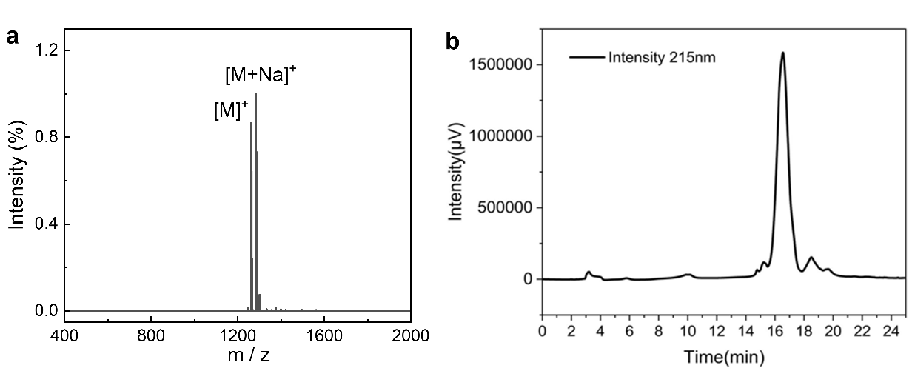
Figure S1. Characterization of KIV tridecapeptide. (a) MALDI-TOF spectrum confirmed the molecular weight of 1262 Da, in agreement of the KIV sequence. (b) HPLC analysis of KIV showed a single peak, excluding the existence of impurity.

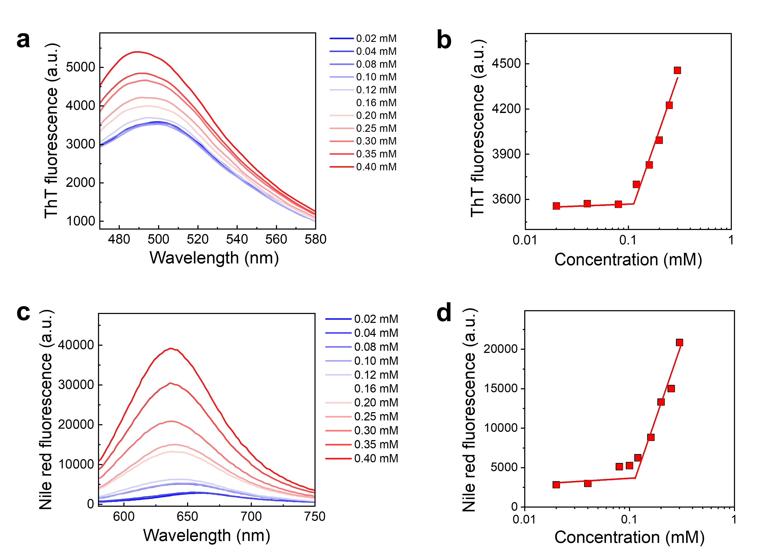
Figure S2. Determination of critical aggregation concentration (CAC) by Nile red and ThT assay. (a) Fluorescence spectra and (b) emission intensity (λ_{em}= 500 nm) of ThT in KIV solution, with an excitation wavelength of 435 nm. (c) Fluorescence spectra and (d) emission intensity (λ_{em}= 650 nm) of Nile red in KIV solution, with an excitation wavelength of 543 nm. Nile Red exhibits strong solvatochromism due to an ultrafast excited-state intramolecular charge transfer (ICT) process coupled with a twisting motion, leading to a TICT molecular state with a high dipole moment. In aqueous environments, Nile Red shows weak fluorescence due to the efficient formation of the emissive TICT state, while in nonpolar environments, its fluorescence is significantly enhanced. CAC was determined to be approximately 0.12 mM.
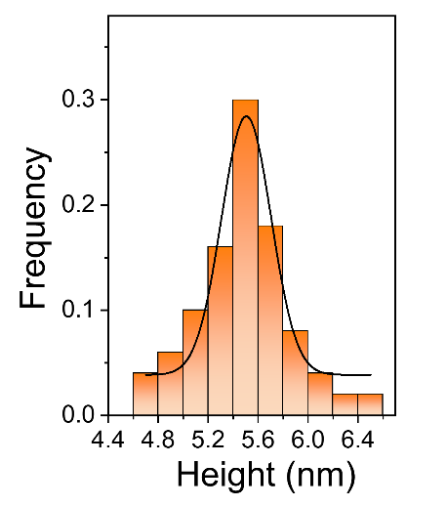
Figure S3. Height distribution of supramolecular KIV fibrils obtained from AFM analysis (Figure 1d). A Gaussian fitting was applied to the data, which provides insights into the variability and statistical characteristics of the fibril heights, indicating an average height of 5.3 nm.

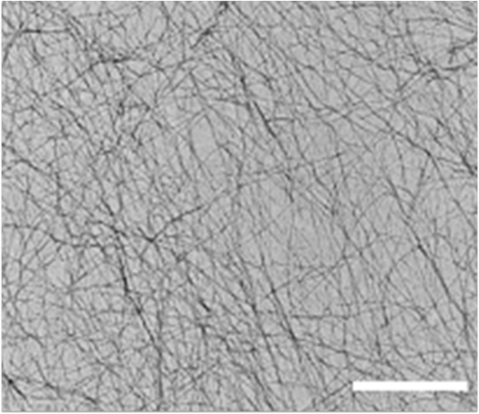
Figure S4. TEM image of amyloid fibrils prepared from KIV. The tridecapeptide solution was prepared with 1.0 mM KIV in HEPES buffer (10 mM, pH 7.5). Scale bar: 500 nm.

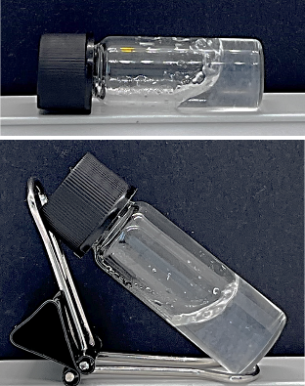
Figure S5. Macroscopic images showing the formation of self-standing hydrogel. The hydrogel was prepared with 5 mM KIV in HEPES buffer (10 mM, pH7.5).
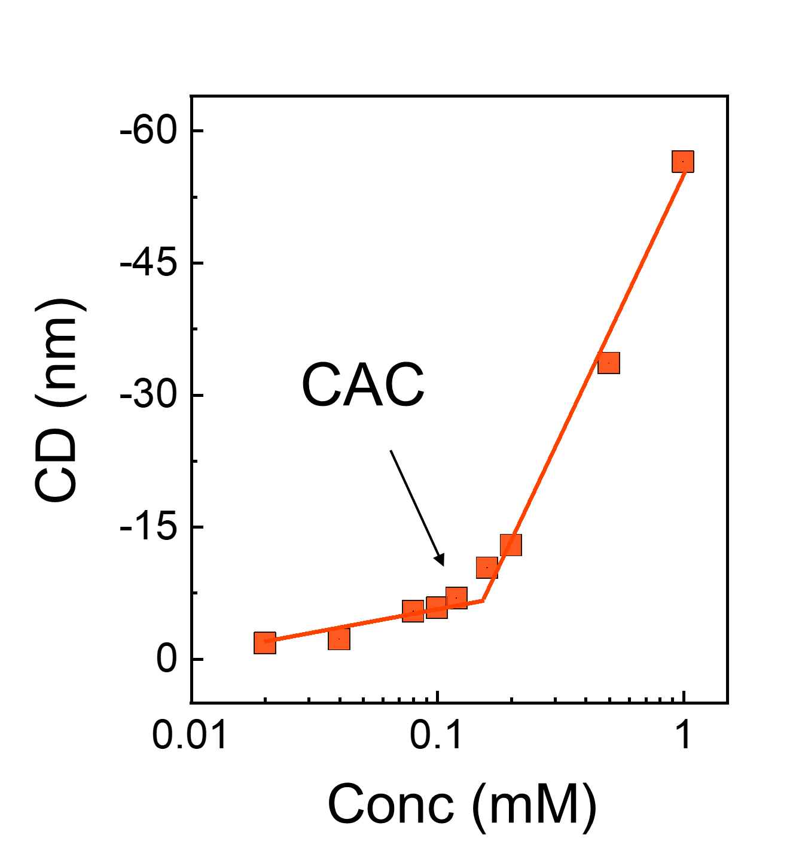
Figure S6. Determination of CAC in tridecapeptide solution. The value of CAC was determined as the turning point by plotting the CD (216 nm) against KIV concentration (0.02 mM to 1.0 mM).

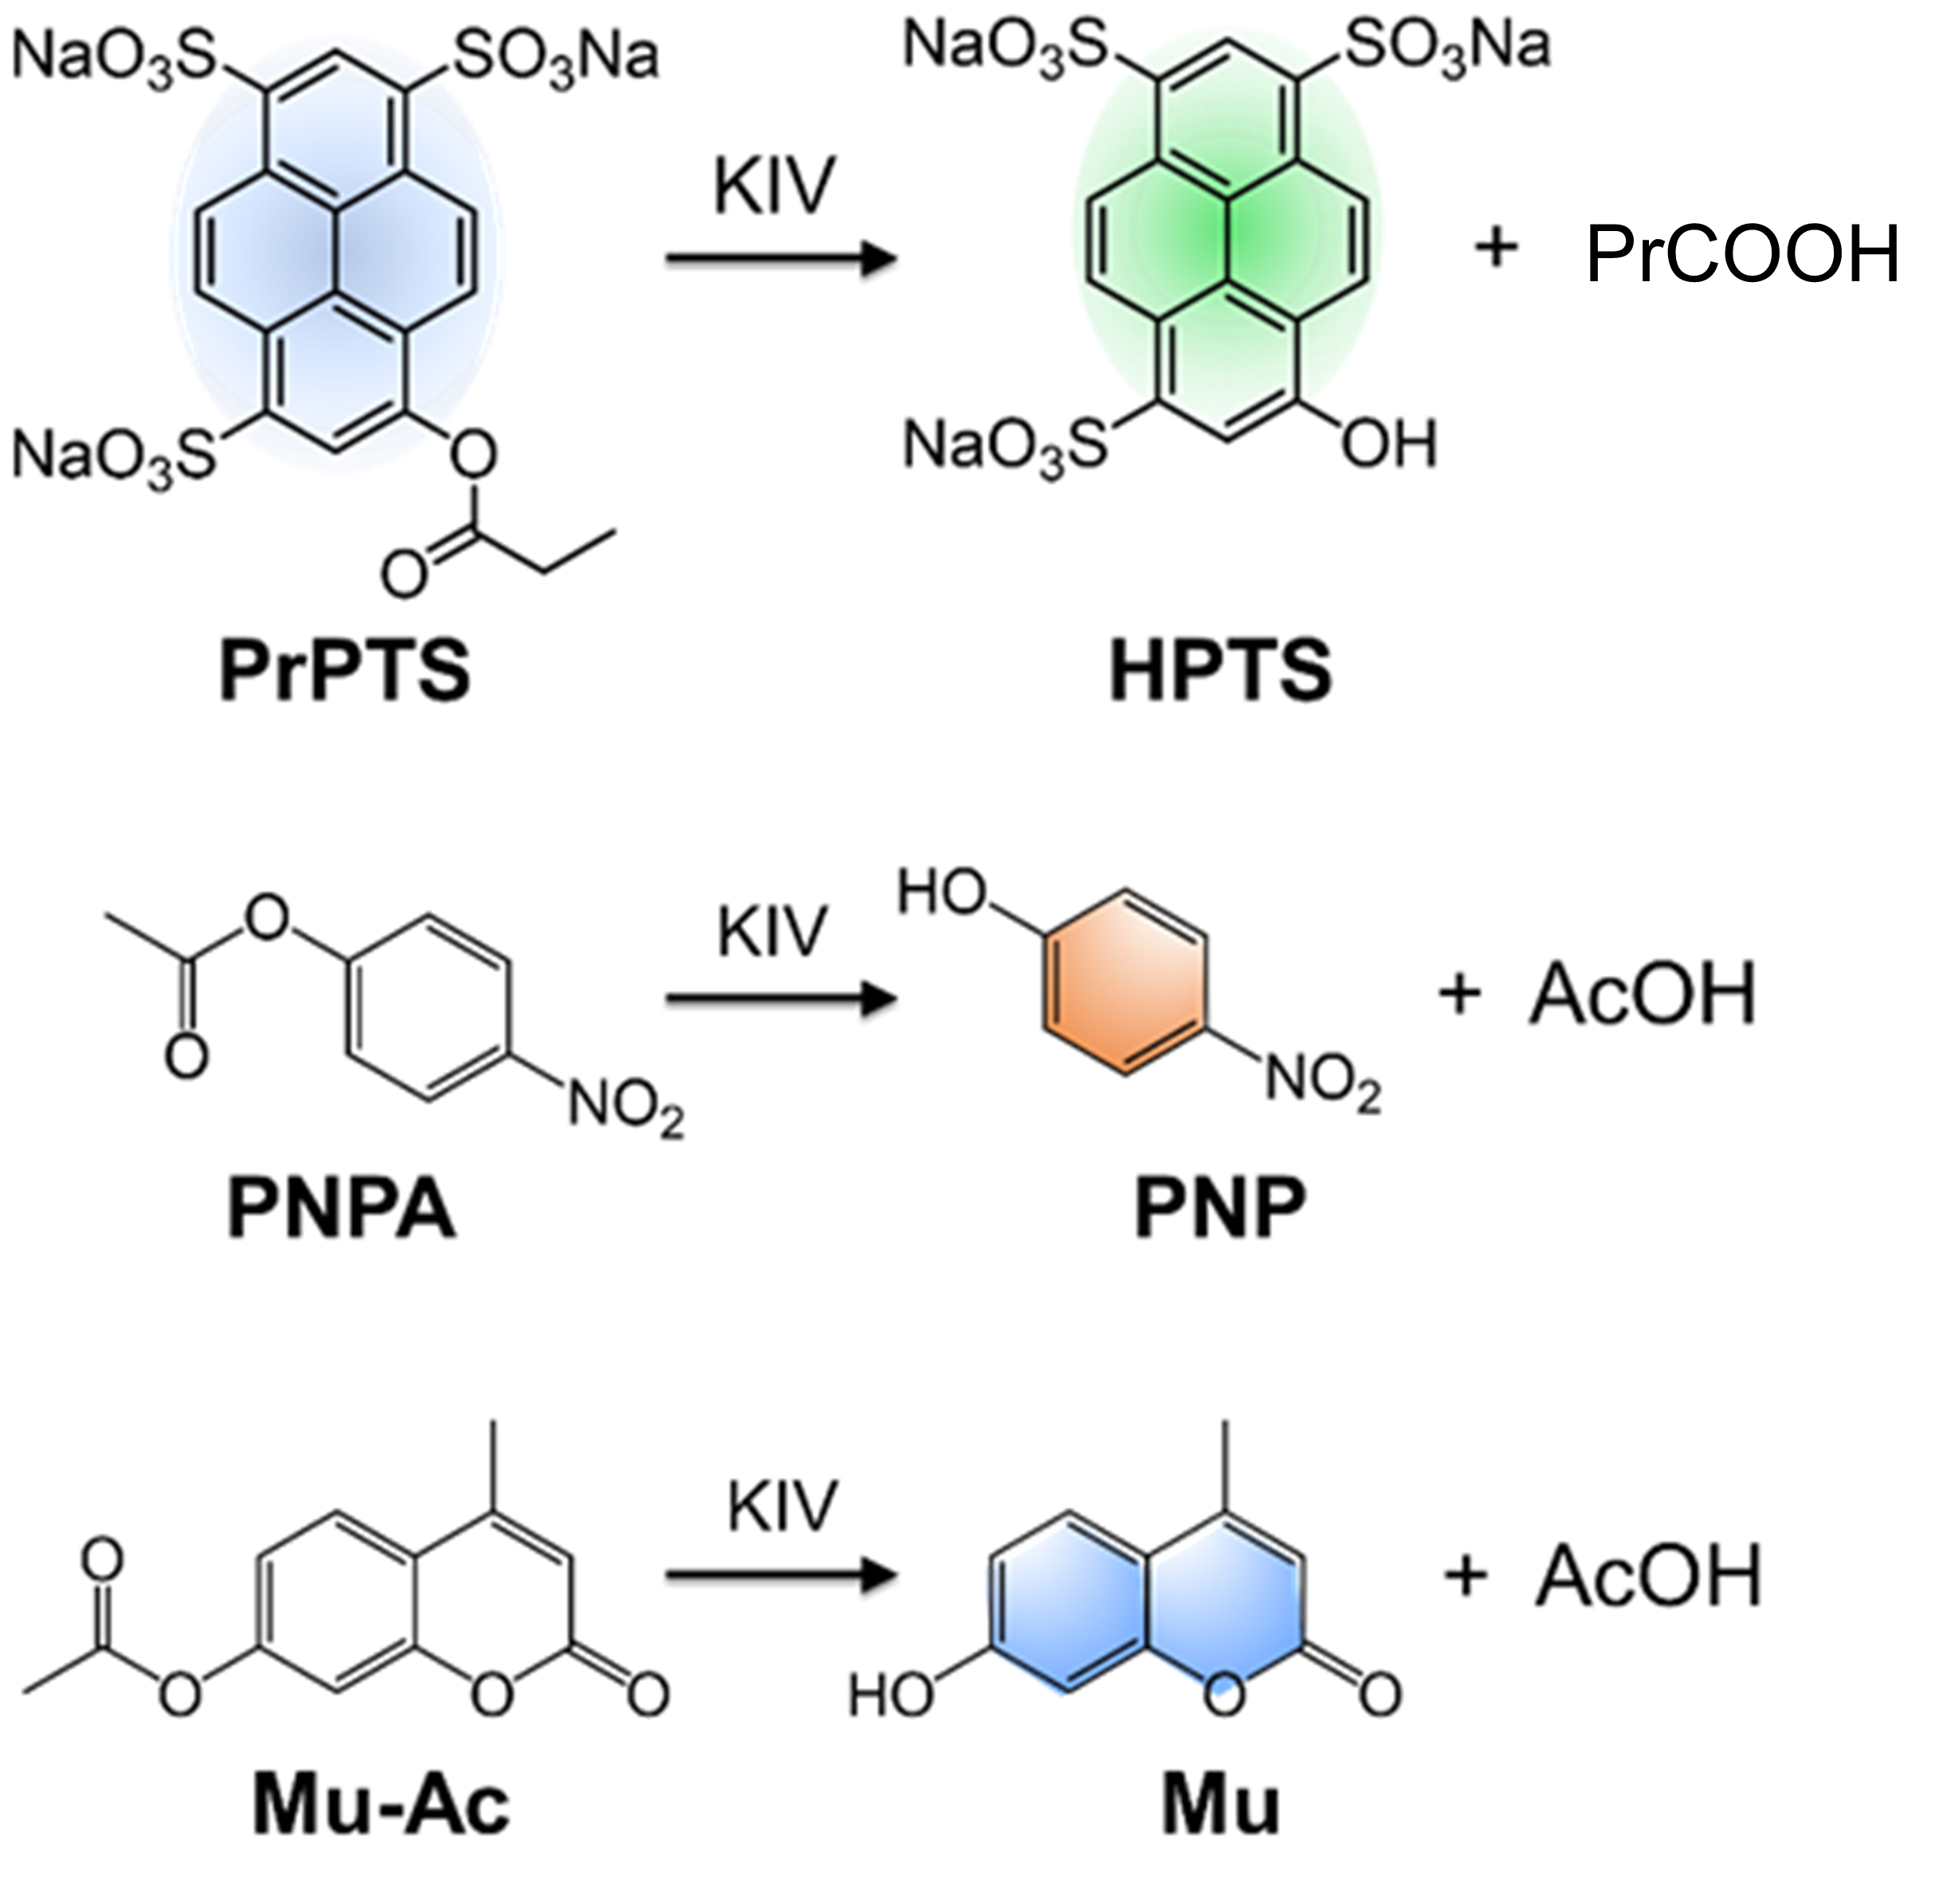
Figure S7. Illustration of hydrolase-like catalytic activity with fluorogenic and chromogenic substrates. Line 1: PrPTS (blue fluorescent) was converted into HPTS (green fluorescent). Line 2: p-nitrophenyl acetate (PNPA) was hydrolyzed into p-nitrophenol (PNP) that exhibited absorption at 410 nm. Line 3: 4-methylumbelliferyl acetate (MU-Ac, non-fluorescent) into 4-methylumbelliferone (MU, blue fluorescent)
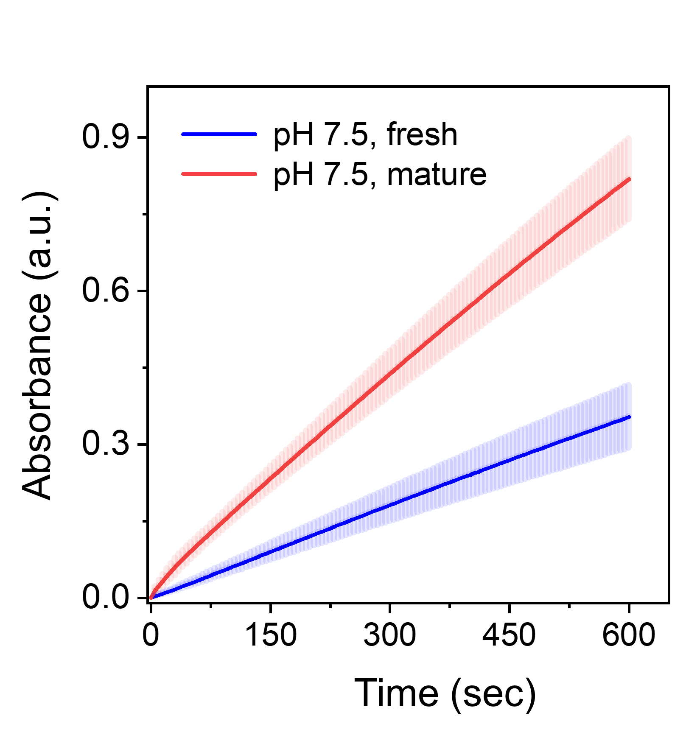
Figure S8. Peptide-catalyzed hydrolysis of p-nitrophenol acetate. Mature KIV nanofibrils displayed higher catalytic activity than the fresh KIV solution.

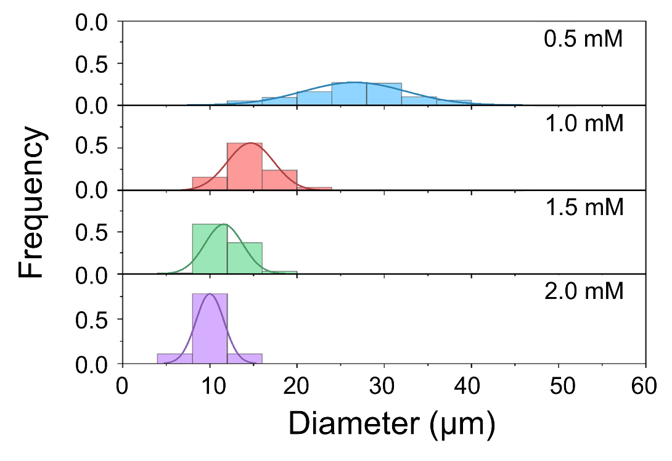
Figure S9. Diameter distribution of o/w Pickering emulsion stabilized with KIV nanofibrils. The chloroform/water volume ratio was 3:7 and the KIV concentration was 0.5 mM, 1.0 mM, 1.5 mM and 2.0 mM. Notably, the emulsion was not stable when the KIV concentration was 0.2 mM.
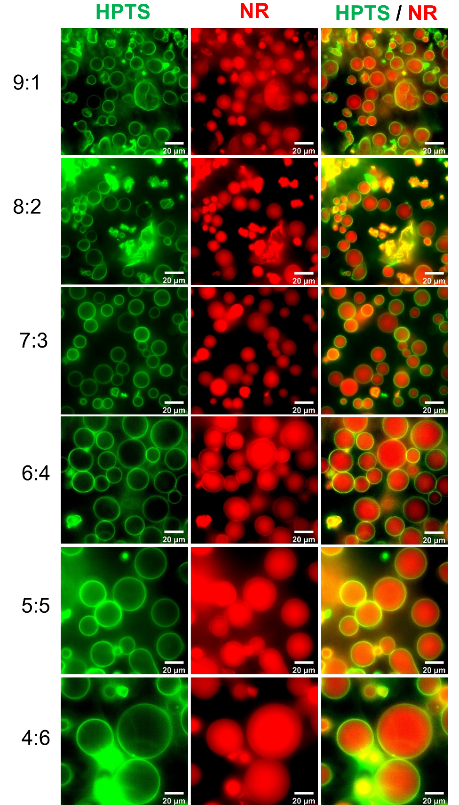
Figure S10. Pickering emulsion stabilized with KIV nanofibrils with varied o/w ratios. The chloroform-in-water emulsion were prepared in a wide range of o/w volume ratio from 9:1 to 4:6. The concentration of KIV peptide and HPTS was 0.5 mM and 5 μM in aqueous phase, respectively. The concentration of Nile red was 5 μM in organic phase. Scale bars: 20 µm.

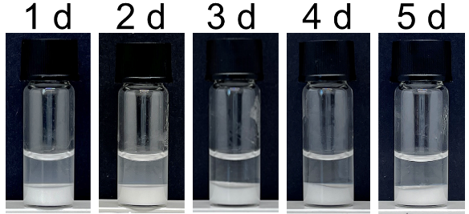
Figure S11. Pickering emulsion stabilized with KIV nanofibrils remained stable for 5 days. The chloroform/water volume ratio was 3:7 and the KIV concentration was 0.5 mM.

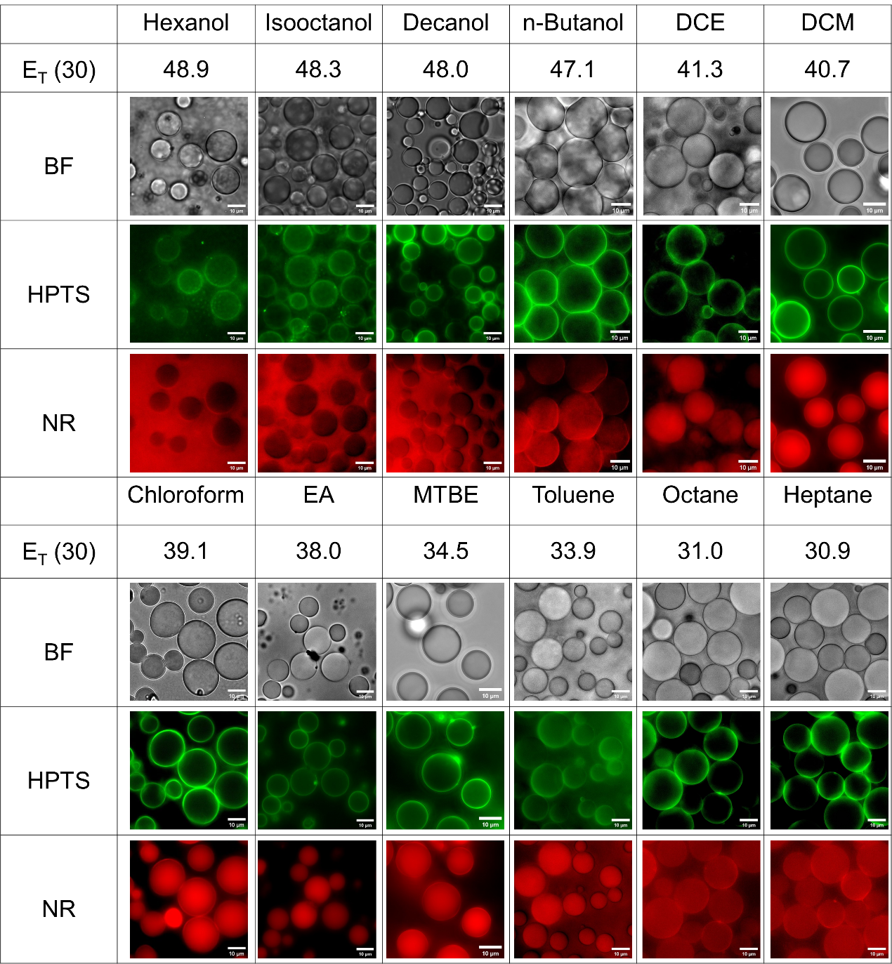
Figure S12. Pickering emulsion stabilized with amyloid fibrils with varied organic solvents. The β-sheet of tridecapeptide fibrils at chloroform-water interface was stained with ThT and the organic phase was stained with Nile red. DCE: dichloroethane; DCM: dichloromethane; EA: ethyl acetate; MTBE: methyl tert-butyl ether. Scale bars: 10 µm.
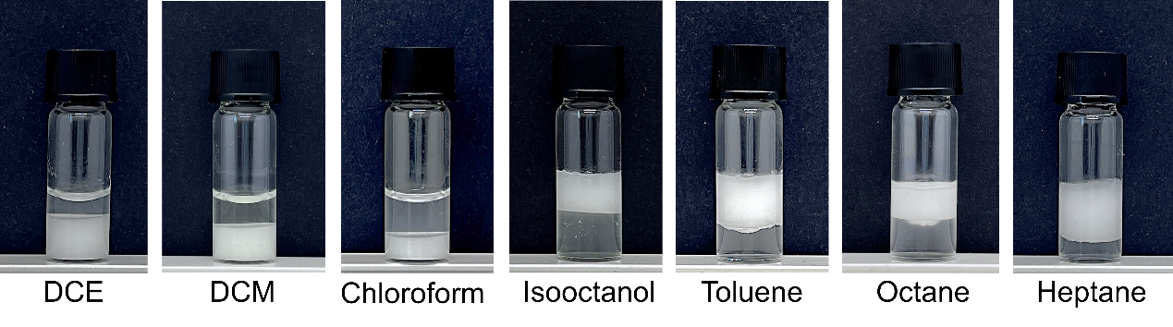
Figure S13. Photos of Pickering emulsions prepared with different solvents. The oil/water feed volume ratio was 30:70 and the concentration of KIV was 0.5 mM.

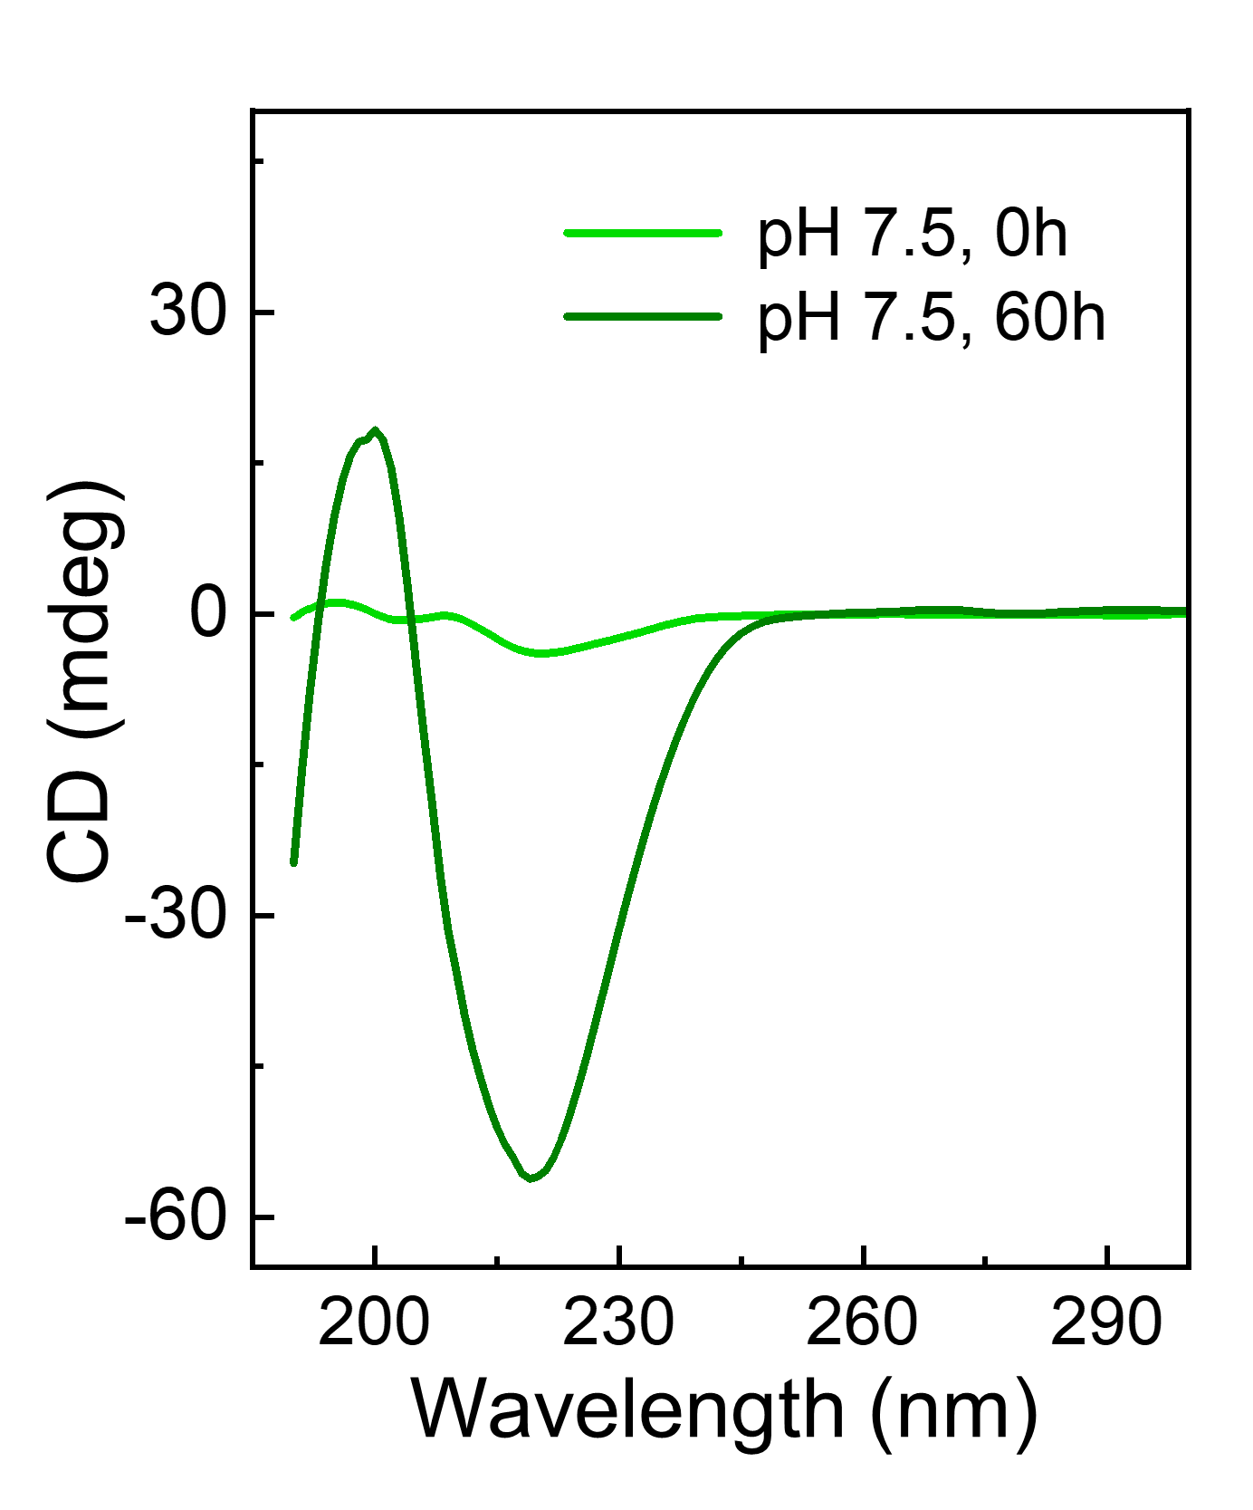
Figure S14. CD spectra of fresh and aged solution of KIV. The peptide solutions ([KIV] = 0.5 mM) were prepared in HEPES buffer (pH 7.5, 10 mM).

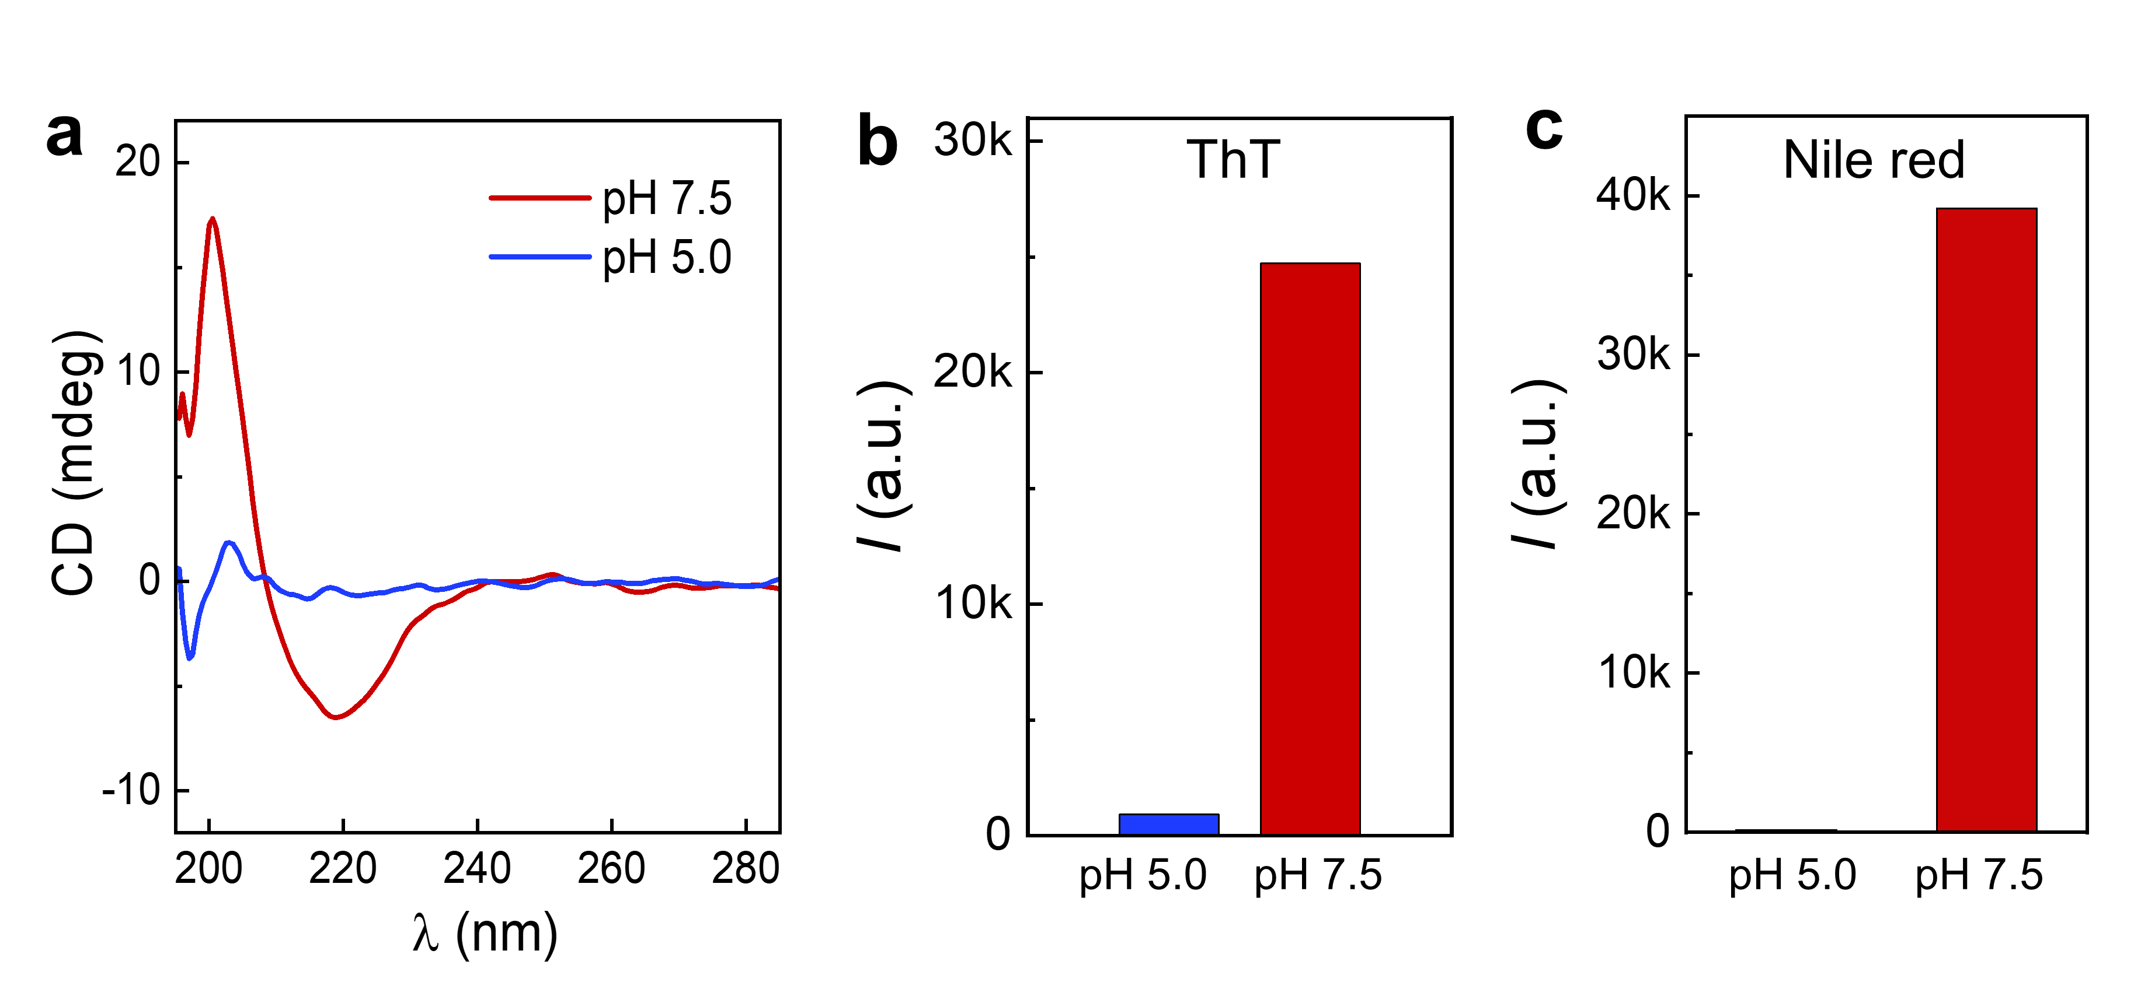
Figure S15. pH effect on KIV self-assembly. (a) CD spectra showing the absence of a negative maximum (λ=216 nm) when solution pH was 5.0. (b,c) Comparison of fluorescence emission from ThT (b) and Nile red (c) at pH 5.0 and pH 7.5. ThT: λ_{ex}= 435 nm, λ_{em}= 500 nm; Nile red: λ_{ex}= 543 nm, λ_{em}= 650 nm.
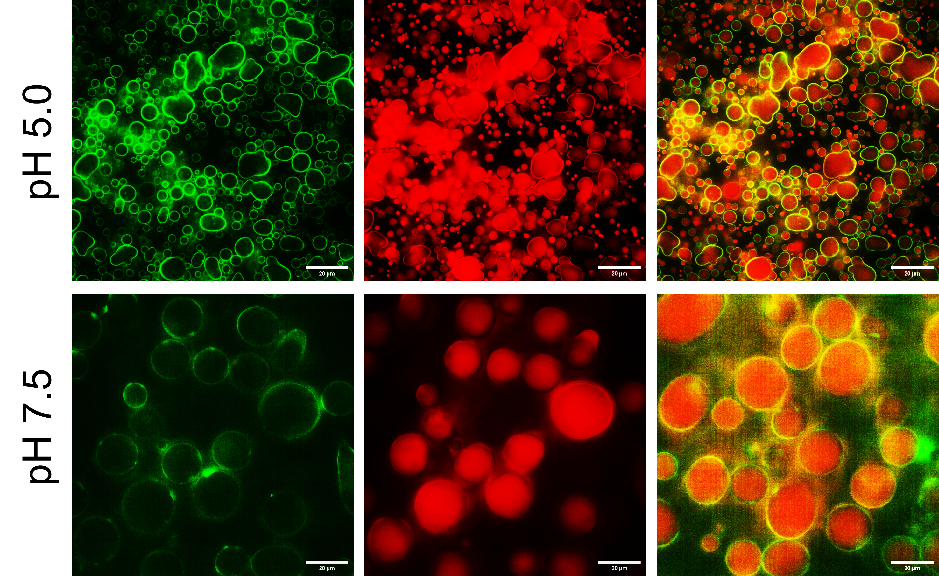
Figure S16. Fluorescence microscopy images showing o/w Pickering emulsion prepared at pH 7.5 and pH 5.0. The oil phase was stained with Nile red and KIV nanofibrils located at the oil-water interface were stained with HPTS. Scale bars: 20 µm.

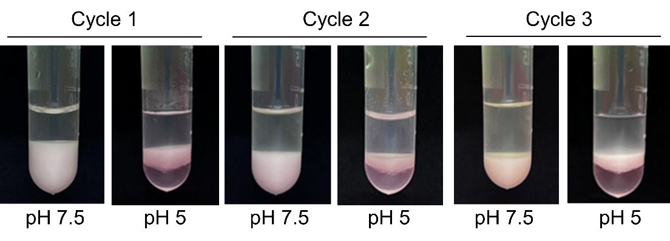
Figure S17. Photos showing the stability of Pickering emulsion under varied pH. Stable emulsion was obtained at pH 7.5 while the emulsion became unstable at pH 5.0. The chloroform/water volume ratio was 3:7 and the Pickering emulsion was formed at the bottom. The top clear layer was aqueous phase. The oil phase was stained with Nile red.

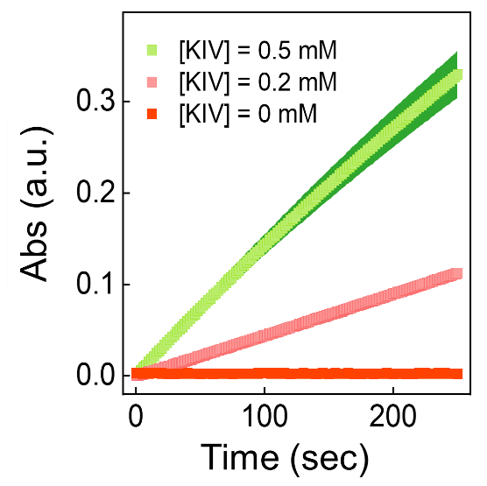
Figure S18. Hydrolysis of p-nitrophenol acetate catalyzed by KIV nanofibrils. Substrate concentration was 1.0 mM and KIV concentration was 0 mM, 0.2 mM and 0.5 mM (pH 7.5). The KIV solution was aged for 60 h to obtain mature nanofibrils. The hydrolysis of p-nitrophenol acetate was monitored by measuring the absorbance at 400 nm over time. The reaction rates of 0.97μM·s⁻¹ and 0.33 μM·s⁻¹ with 0.2 mM and 0.5 mM KIV, respectively.

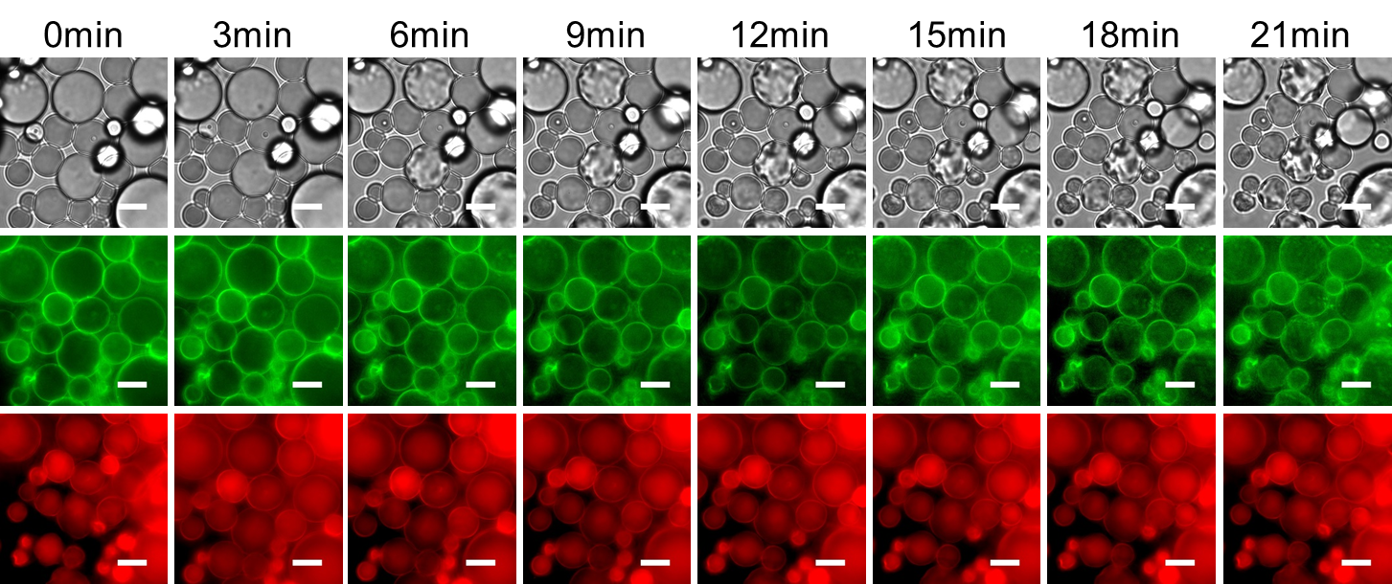
Figure S19. Microscopic images showing the stability of Pickering emulsion. During substrate hydrolysis, no morphological changes were observed in the o/w Pickering emulsion droplets. The substrate concentration was 1.0 mM, and the KIV concentration was 0.5 mM in HEPES buffer (10 mM, pH 7.5). The chloroform-to-water volume ratio was 75:25. Red indicates Nile red, and green indicates HPTS. Scale bars: 10 μm.
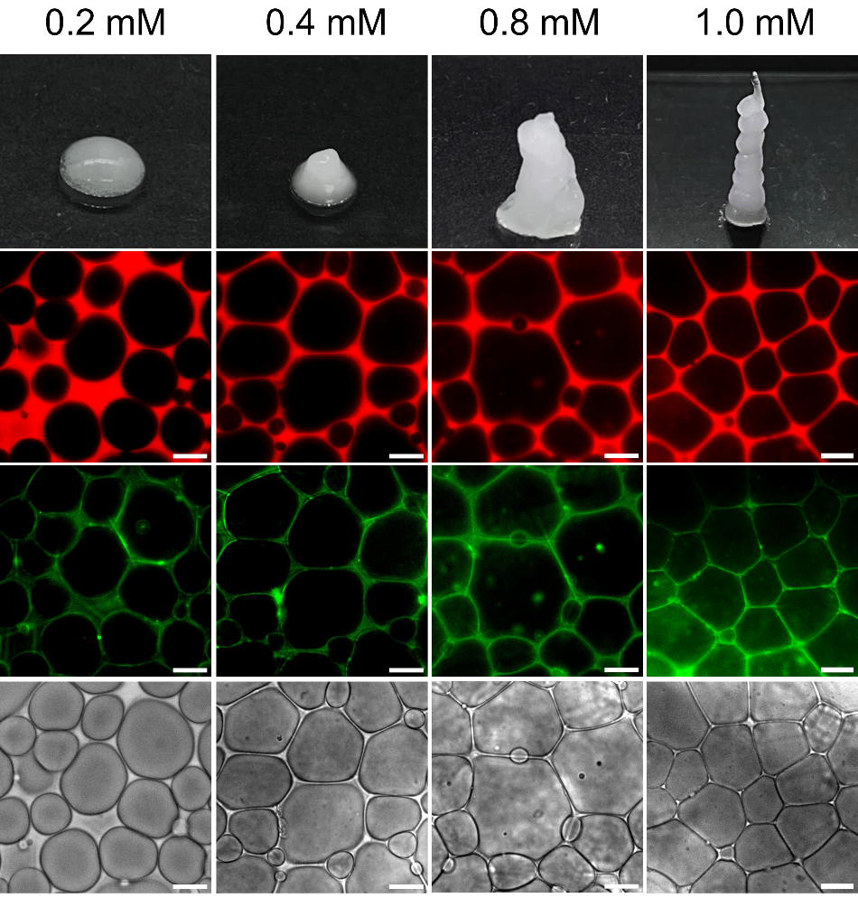
Figure S20. Formation of w/o HIPE gels with varied KIV concentrations. The oil phase was stained with Nile red and the KIV nanofibrils were stained with ThT. The chloroform/water volume ratio was 25:75. Self-standing emulsion gels was obtained at the KIV concentration of 0.8 mM and 1.0 mM. Scale bars: 20 µm.

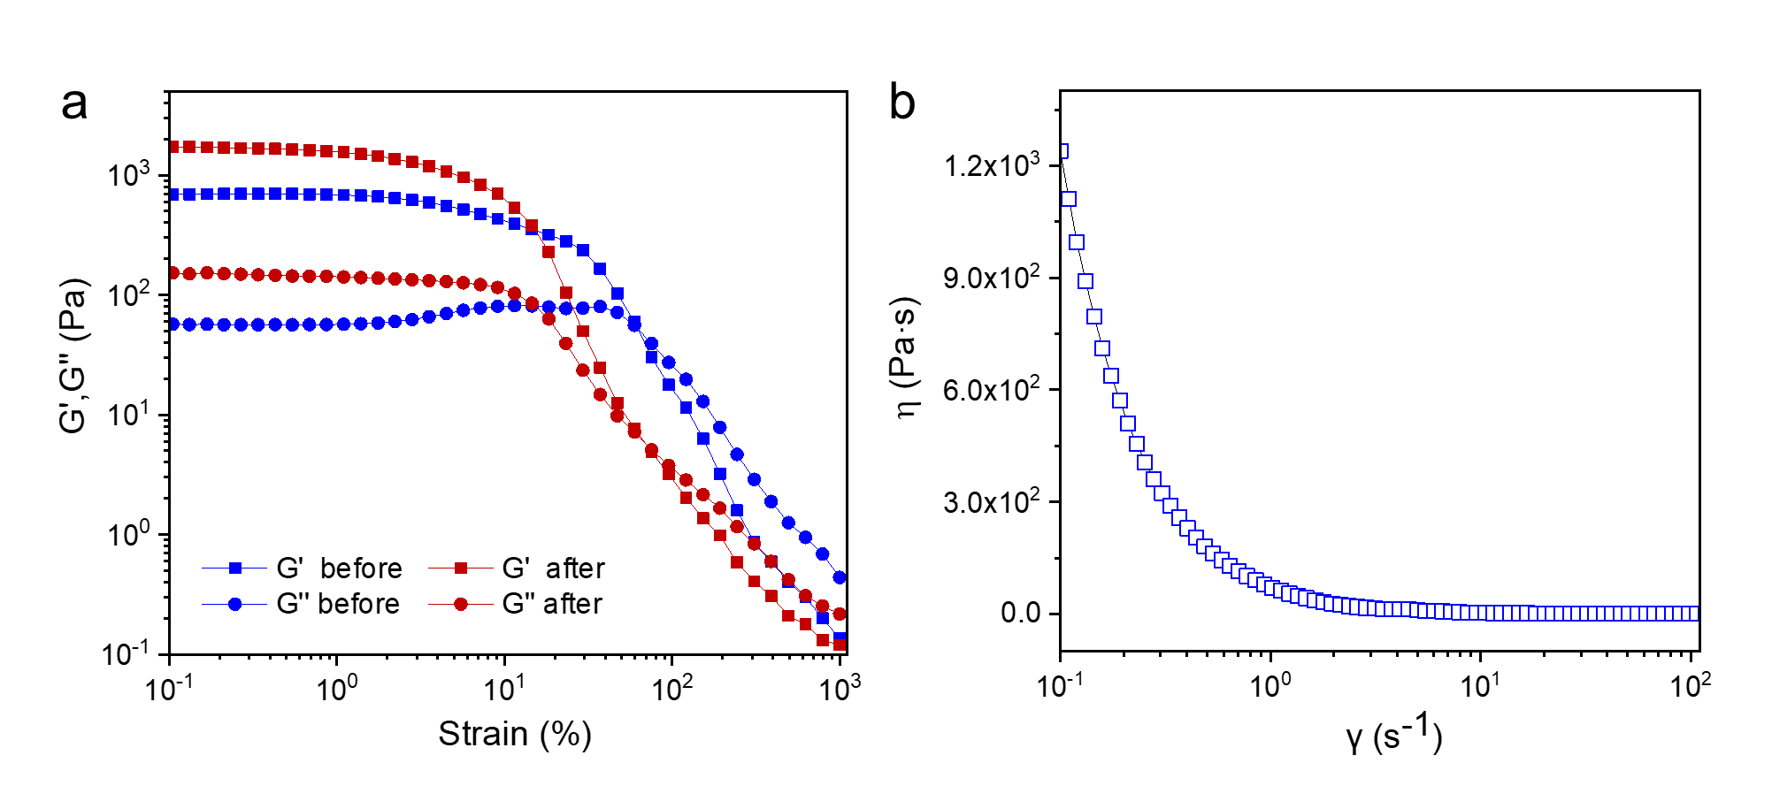
Figure S21. Rheological characterization of HIPE gels before and after printing. (a) Dynamic rheological measurement showing the variation of storage modulus (G’) and loss modulus (G’’) against shear strain. It is shown that the HIPE gels retained higher G’ and G’’ after printing. (b) Viscosity of w/o HIPE gels (before printing) under steady shear, showing a shear-thinning effect.

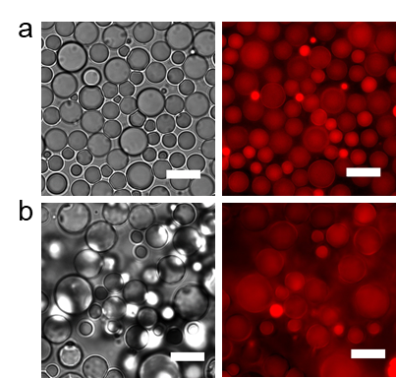
Figure S22. Optical and fluorescence microscopy images of Pickering emulsion stabilized by peptide fibrils. (a) Ac-SSNNFGAIL, (b) Ac-EFFFFFE. The substrate concentration was 1.0 mM, and the peptide concentration was 0.5 mM in HEPES buffer (10 mM, pH 7.5). The chloroform-to-water volume ratio was 25:75 and the organic phase was stained with Nile red. After homogenization, the o/w emulsion droplets did not undergo phase transition to form HIPE gels, suggesting the indispensable role of histidine and catalytic hydrolysis of substrate in inducing phase transition. Scale bars: 10 μm.

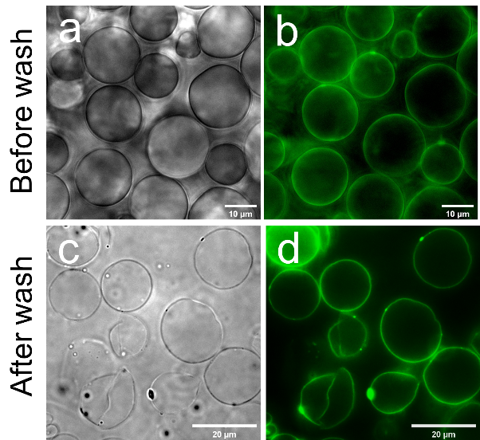
Figure 23. Optical and fluorescence microscopy images showing the formation of silica scaffold on o/w Pickering emulsion. The silica phase was labelled with FITC-APTES. The silica shell was highly robust even after the removal of solvents. Scale bars: (a,b) 10 µm; (c,d) 20 µm.

Table 1. Michaelis-Menten parameters of catalytic reaction using PNPA as a substrate.
V_{max} / μM·s⁻¹ | K_{m} / mM | K_{cat} / ×10⁻³ s⁻¹ | K_{cat}/K_{m} / mM⁻¹·s⁻¹
4.51 | 0.35 | 9.02 | 25.77

